1. Open histoToCSV.m and update lines 6 and 9 to be the histology and binarized histology image and run the script
2. Open the csv file to check the x (column 1) and y (column 2) max values (example csv is x max 480 and y max 393)
3. Update the x and y values in the MuscleRegenInitalizer.xml in line 14
4. Update the file location of the csv in the MuscleRegenInitalizerSteppables.py line 14
5. Depending on the size of the histology image decide if you want to downscale and update that on line 16
6. Start the Compucell3D player and open MuscleRegenInitializer.cc3d
7. Once the fibers grow to fill all the space within the between the ECM save the PIFF by going to the tools tab and clicking on generate piff file from current snapshot. NOTE: This must be done before you stop the simulation

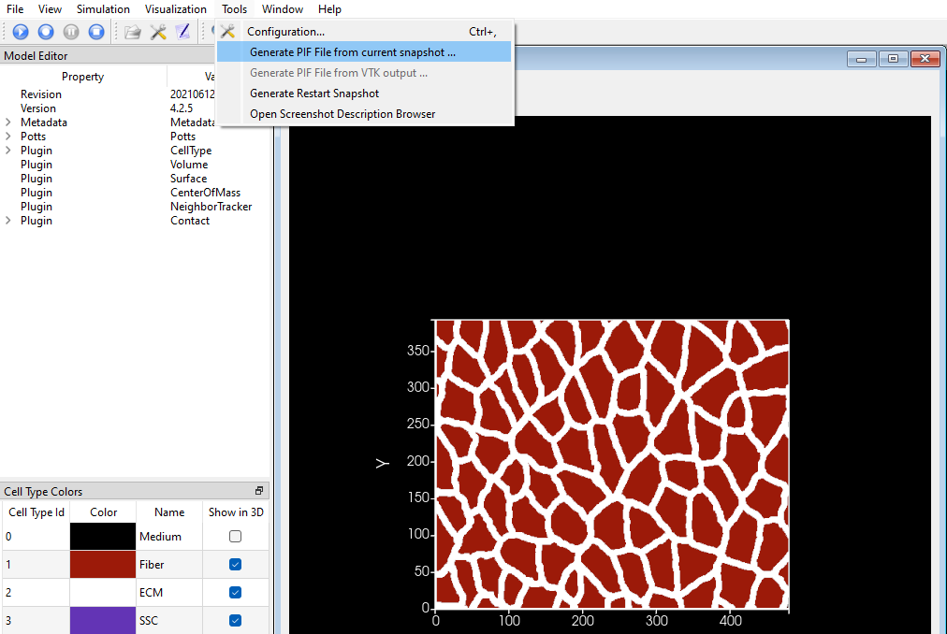

1. Add this piff to the xml under the PIFInitializer
2. In the MuscleRegenInitalizerSteppable under the LymphaticSteppable, update the location of the lymphatic vessel
3. In the MuscleRegenInitalizer.py file comment the MuscleRegenInitalizerSteppable and uncomment the MitosisSteppable, MakeCapillarySteppable, and the LymphaticSteppable. NOTE: This will take a while because it’s looping over all ECM and fiber elements
4. Once incomplete fibers are removed, capillaries are added, and lymphatic vessel is placed save the pif snapshot

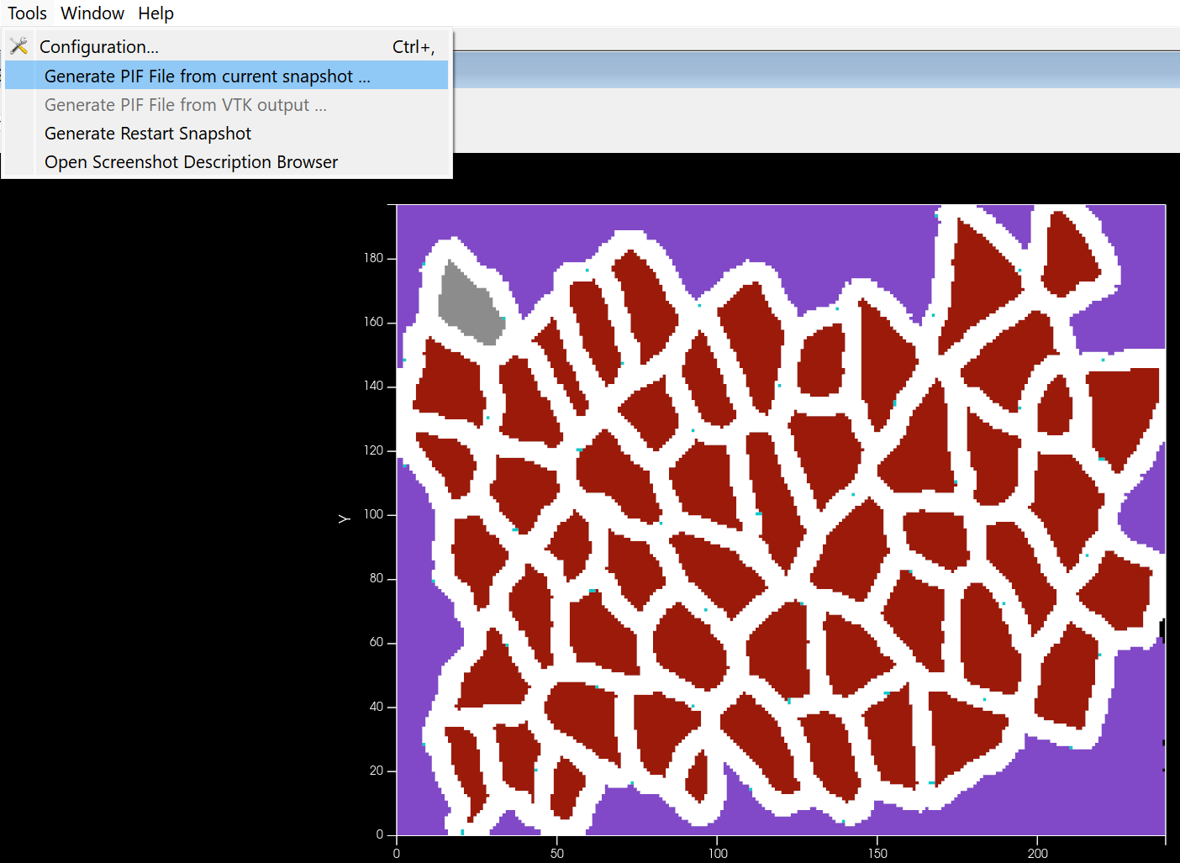

1. The pif file is now ready to use in the main simulation. Copy the pif file to the location of the CC3D muscle regen model source code. In the xml file of the main model add the file name to the xml under the PIFIntializer and update the x and y dimensions. In the steppables file update the dimensions under the variables sections.